On the Approximability of Numerical Taxonomy

(Fitting Distances by Tree Metrics)
R. Agarwala, V. Bafna, M. Farach, B. Narayanan, M. Paterson,
and M. Thorup
Proc. Of the 7th Annual ACM-SIAM Symposium on Discrete Algorithms, 1996
- Introduction
First we present an O(n²) algorithm for finding an additive tree T such that 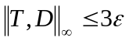, giving the first algorithm for this problem with a performance guarantee. Second we show that it is NP-hard to find a tree T such that 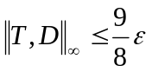
- Preliminaries
Definition 2.1 A metric D is additive if, for all points a, b, c, d,
D[a, b] + D[c, d] <= max{ D[a, c] + D[b, d], D[a, d] + D[b, c]}.

Theorem 2.1 A metric is additive if and only if it is a tree metric.

Definition 2.2 A metric D is an ultrametric if, for all points a, b, c
D[a, b] <= max{D[a, c], D[b, c]}.

Definition 2.3 A metric D is a centroid metric if 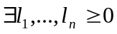 such that 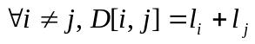
- Upper Bound
Definition 3.1 Let D be a distance matrix. For any point a, define m_{a}=max_{i}{D[1, i]}. Let Cª be the centroid metric with l_{i}=m_{a}-D[a, i], i.e.,
Cª[i, j]=2m_{a}-D[a, i]-D[a, j].

Lemma 3.1 D is additive if and only if D+Cª is an ultrametric.
Definition 3.2 For point a, we say a metric M is a-restricted if 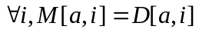.

Theorem 3.1 Given an n*n distance matrix D, we can find a tree T in O(n2) time such that 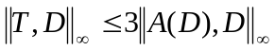
- Lower bound
Theorem 4.1 It is an NP-complete problem to determine for a given distance D and a threshold if 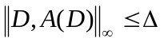.

Theorem 4.2 It is an NP-hard problem, given a distance matrix D, to find an additive metric T such that 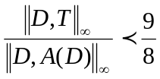
- Generalization to Other Norms
Theorem 5.1 If A(D) is an algorithm which achieves an -approximation for the a-restricted Ultrametric_{k} problem and runs in time T(n²), then there is an algorithm F(D) which achieves a 3-approximation for the Additives_{k} problem and runs in O(nT(n²)) time.
Created by: Chia-Mao Huang
Date: Dec. 12, 2000

